# Game Design Document and Technical Design Document - Vegistation

***This Document contains both the GDD (Game Design Document) and TDD (Technical Design Document)***

## **Contents**

**Game Outline (Page 3)**

*Chosen genre*

**Characters and Controls (Page 3)**

*Main Character*

*Character Designs*

*Character Specifications*

**Main Gameplay (Page 3 – 4)**

*Objectives*

*Goal*

**Game World (Page 5)**

*Level Design*

**Gameplay Mechanics (Page 6- 7)**

*Mechanics*

**Enemies (Page 7 – 12)**

*Ai Behaviour*

**Cutscenes (Page 12)**

**Choice Of Game Engine And Why? (Page 13)**

**Assets And More (Page 13)**

*Furniture*

**Enemies (Page 13 -14)**

*Enemy Designs*

**Hardware/Software Requirement (Page 15)**

**Bibliography (Page 15)**

**Prototype Description (Page 16-17)**

## Game Outline

The chosen genre for this project is horror and puzzle.

The game is set inside a laboratory. The player will explore the laboratory after being sent to the building to solve puzzles, defeat mutations and remove the mutations from existence.

The horror aspect will be the environment and the mutations along with the ambiance, sounds and effects that the environment will give off along with the eery sounds the mutations will make.

The puzzle aspect will consist of finding items and placing them in correct orders, electrical based puzzles, piecing together collective information for formulate final results and creating mixes of formulars to match the result with guidance from finding the final collective information to help remove, and exterminate, the mutations before spreading.

The game will be targeted at those above the ages of twelve.

## Characters And Controls

Our Main character of this game will be a scientist working in a laboratory as they are working on perfecting on enlarging vegetables to solve lack of resources and food. During the start of our game the player scientist will be having a day off at home was not present for the disasters about to inflict harm on many lives.

This game will be a first-person point of view game which means it will not matter what the character looks likes.

The player will be able to hold items and weapons within the games allowing them to complete puzzles, pass enemies and collect intel on the current situation they missed and how they can fix the mess they were assigned.

## Main Gameplay

The main aim of the game is to defeat the mutated vegetables and stop the spread and growth of the mutations. The player must stop the army of vegetables growing to survive and leave the laboratory in one piece.

The game starts with a cutscene of scientist from the laboratory conducting their experiment before disaster strikes and the experiment goes wrong, in a last resort to stop the research from spreading outside the containment area they call you, the player, to come to the laboratory on your day off by leaving a message of distress and urgency.

The player processed to head to the laboratory in the dark as they reach the entrance. The interactive gameplay will start as they will enter and after some searching will discover blood stains and marks on the ground as no survivors are in sight. The player must find out what happened. There being security cameras they can look at the surveillance footage to find out what happened, however, there will be no power and the first puzzle of the game will be to restore power which will introduce the player to puzzles and encourage them to search for items.

Once the player has restored power the elevators will be up and running again allowing the mutated carrot to come up to the floor, the player will encounter the mutated carrot and learn about the attacking mechanics of the game.

Once proceeded they will head to the next floor where they will see the blood stains and mess from the remains of the failed experiment. The player will complete puzzles to get around, find information on how to stop the mutation. They will encounter more enemies them being more difficult to fight and hold up against.

Once the player reaches the bottom, they will prepare the solution to wipe out the mutated creatures in the sprinkler system, however, they will encounter the boss first, the boss will be a large mutation as the player will have to face off against it with the weapons they have collected on the way.

After the boss is taken down the player will complete the last and final mission where they will finish the game leaving the building after exterminating the mutations.

## Game World

**Security Room**

**Cafeteria**

**Stairway – No Entry**

**Freezer – No Entry**

**Meeting Room**

**Storage 2**

**Storage 1**

**Staff Break room – No Entry**

**Power Room**

**Male Toilets**

**Kitchen**

**Female Toilets**

**Elevator**

**Office 2**

**Office 1**

**Front Entry – Players Starting Point**

**Rooms**

**Front Entry** will be where the player starts, the **Staff Breakroom** is locked and non-accessible to the player. Going through the corridor the **Elevators** will be unavailable until the player restores the power in the **Power Room**, but in order know they must restore power they will be directed to the **Security Room** finding out that none of the screens are operational due to the power being out. The player will then travel to different rooms in the map such as **Office 1** and **Office 2**; they will also search in **Storage 1** and **Storage 2** to get power fuses to put in the power box in the **Power Room**. The player can explore the meeting room for tapes and files for information.

## Gameplay Mechanics

**Player:**

**Items:**

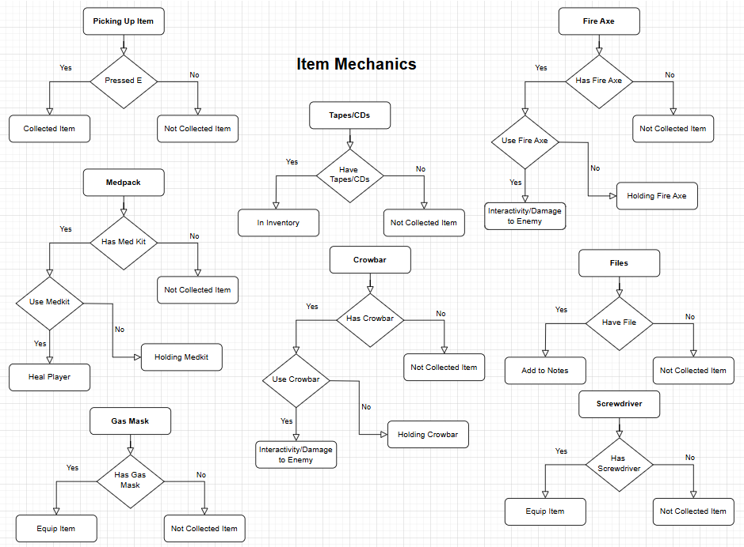

**Enemies:**

## Enemies

In this game there are six types of enemies and a boss. The enemies and boss are all mutated vegetables.

Each enemy has a different unique way of moving and attacking. The player will encounter different enemies on different levels and in different rooms specific to their nature and the boss can be found at the end of the game in the last room the player will be sent too.

On the first level the player will encounter the lower tier of enemies.

**The Lower Tier:**

The Models below were made from clay to represent the design of the characters.

**The Carrot**

The Carrot is the first enemy the player will encounter.

Movement:

* Slow Movement
* Hops around on one leg
* Patrols Rooms

Attack and Abilities:

* Medium distance
* Long slender arms
* Weak attack
* Has no special ability

Heath, Damage and Weak points:

* Has 60 HP
* Deals 5 damage per hit
* Main Body is weak point

**The Tomato**

Movement:

* Slow Movement
* Hops around
* Stays Idle in Rooms will follow player

Attack and Abilities:

* Long distance
* Spits tomato seeds at Player
* Weak attack
* Leaves tomato juice on the ground, player will slip on it

Heath, Damage and Weak points:

* Has 30 HP
* Deals 10 damage per hit
* Main Body is weak point

**The Mushroom**

Movement:

* Doesn’t move
* Stays Idle in Rooms on the ground

Attack and Abilities:

* Medium range
* Explodes like a landmine when the player stands on then
* Medium attack

Heath, Damage and Weak points:

* Has 10 HP
* Deals 30 damage per explosion
* Main Body is weak point

**The Higher Tier:**

**The Onion**

Movement:

* Speed: Slow, tends not to move
* Will roll around and stop in areas

Attack and Abilities:

* Sprays tear gas from its mouth
* It does not have a physical attack

Heath, Damage and Weak points:

* Has 50 HP
* When is moving damage reduction will be in place
* Will make the player's vision blurry and make the player loose health by suffocating on the gas
* Takes 2 damage every second

**The Corn**

This Enemy will have legs and arms made of the stork and leaves

Movement:

* Slow Speed
* Walks with feet having a slow pace but makes a heavy stomping noise
* Patrols areas being mostly blind from behind and if player crouches, they will not be seen unless they get too close to the front of it

Attack and Abilities:

* Short distance attack as slams fists down and feet
* Shoots Corn at you for a long-distance shot

Heath, Damage and Weak points:

* Has 80 HP
* Deals heavy damage to the player
* Weak spot is the yellow corn, green shell shields from most of damage

**The Broccoli**

This Enemy has a spring at the bottom to move around

Movement:

* Fast Movement but tends to stand still when player is in range
* Will move closer to player if they get further away
* Uses spring at bottom to bounce around
* Springs around in rooms, will follow player

Attack and Abilities:

* Uses Purple eye to force player to look at them taking health away slowly
* Eye will make the players the players screen purple if spotted

Heath, Damage and Weak points:

* Has 40 HP
* Weak point is Eye
* If eye is shot, then it will close the eye for 5 seconds allowing the player to remove the purple glow and ringing noises, will also prevent health from being lost
* Will take 5 HP when purple glow is fully visible on boarders of screen

## Cutscenes

During this game there will be cutscene.

**The First Cutscene**

Staff within the Laboratory will experience an experiment go wrong as one of the employees will send the player an alert message to come into the laboratory to the player on their day off. The player will leave their home and head out for the Laboratory.

**The Second Cutscene**

The player will switch on the power which will restore the elevator it now in operation. The elevator will be sent down. The player will review over the footage watching as the vegetables during the experiment mutate an attack the employees, while the player is watching the footage the elevator is still making its way down. Once the footage has ended the elevator will have made it’s way to the top, as the doors open it will reveal that there is a mutated carrot that has travelled up the elevator the player unaware.

**The Third Cutscene**

Player will encounter boss in the testing chamber.

**The Forth Cutscene**

Player will leave this place alive and uninfected

## Choice Of Game Engine And Why?

Our choice of game engine is unreal engine.

The reason we have chosen such a powerful game engine is because it has unlimited potential and is continuously improving becoming the future game engine for gaming.

Unreal Engine offers a realistic style of gameplay primarily; however, this does not mean that it only offers a realistic type of game style, it also offers different styles. Our focus is to look at a slightly more less realistic style.

## Assets And More

Since this is level designed based, the assets will be mainly furniture and table side assets such as stationary, laboratory equipment and more.

## Enemies

## A hand holding a green object with a eye and a purple eye AI-generated content may be incorrect.A hand holding a mushroom AI-generated content may be incorrect.A hand holding a painted pumpkin AI-generated content may be incorrect.A hand holding a corn cob AI-generated content may be incorrect.A hand holding a yellow object with a face AI-generated content may be incorrect.A hand holding a pumpkin AI-generated content may be incorrect.

## Hardware/Software Requirements

Since the choice of game engine for this game is Unreal Engine getting the right hardware will be critical.

Unreal Engine is a high-powered engine and requires at least 8GB of Ram to be able to access its minimum potential. Software such as Blender requires the similar amount of ram usage but it all depends on how many models you make or what tools you use within blender.

Blender can use addons from outside sources which can take up extra processing power but the same could be said about Unreal engine.

Unreal Engine can import in textures, packages and asset files which can increase the size of the project massively.

Blender depending on preference can be used with a Digital tablet with or without a screen. Digital tablets are most useful for sculpting and painting textures onto models UVs, by setting key binds on the side of the pen it can be set to whatever the user preference is and can be adjusted at any time making it an extremely useful tool for those who enjoy shortcuts which blender mostly relies on and makes things quicker for experienced users or users who like to advance faster and more efficiently. Overall, the Digital Tablets are a great addition to blender and with great personalisation available the user can get work done effectively.

The overall requirements for this production process are using a high-powered computer capable of supporting high ram usage and high-performance ratings along with an additional Digital Tablet for blender usage to increase performance and detail work.

## Bibliography

SmartDraw, Free to use Blueprint maker

<https://app.smartdraw.com/?nsu=1>

Mural, a free to use mood board maker

<https://youtu.be/n4ri8ul_uzs?si=5g03aMwyyVcm2LXm>

Character Mood Board

<https://app.mural.co/t/fishbowl3d4545/m/fishbowl3d4545/1738330322618/919f7ea656d7f55c3e01f211f343e052071ece82?sender=u201384d5e318bff83ebc6919>

Unreal Engine 4 Character Model Size Reference

<https://sketchfab.com/3d-models/unreal-engine-4-character-815b7d1a78f646e3a1614236351377a4>

Desk size reference:

<https://www.office-furniture-direct.co.uk/dynamic-impulse-1800mm-left-crescent-desk-beech-top-silver-cable-managed-leg-workstation-600-deep-desk-high-pedestal-bundle>

Small cupboards size reference  
<https://www.office-furniture-direct.co.uk/dams-executive-pedestal-3-drawer-426-x-600mm>

Chair size reference

<https://www.officeboffins.co.uk/airform-24-hour-ergonomic-fabric-office-chair.html>

Meeting Room TV Size Reference  
<https://www.samsung.com/us/business/displays/direct-view-led/ia-series/the-wall-all-in-one-146-p84-lh008iabmus-go/#specs>

Oven Size Reference

<https://www.amazon.in/Thor-Kitchen-Stainless-Burner-LRG3001U/dp/B072Z235MH>

Fridge Size Reference

<https://www.eurocatering.co.uk/products/restaurant-fridge-commercial-fridge-1>

Cafeteria Table Size Reference

<https://www.idfdesign.com/straight-metal-or-plastic-tables/pegaso-solid.htm>

Cafeteria Chair Reference  
<https://www.franciscosegarra.com/en/furniture/seats-for-cafeteria/>

Storage Rack Size Reference

<https://www.tufferman.co.uk/products/2x-crw-industrial-shelving-2000mm-high-500kg-grey?variant=54897956487546>

Circuit Breaker Size Reference

<https://www.ebay.ph/itm/165512568744>

<https://i.ebayimg.com/images/g/lGUAAOSwI8xil6ub/s-l1200.jpg>

Plate Size Reference  
<https://www.amazon.co.uk/I-K-OFTAST-Plate-White/dp/B09CDFHDK8?source=ps-sl-shoppingads-lpcontext&ref_=fplfs&psc=1&smid=A1VMD3OYB995G8>

Sink Size Reference

<https://usedrational.co.uk/product/stainless-steel-commercial-sink-with-2-big-bowls-with-self-underneath/>

Bin Size Reference

<https://www.buzzcateringsupplies.com/grey-round-huskee-bin-75l.html?srsltid=AfmBOooEBHiN0ZvKUiMvo1A3wAauU96JHPJSbbj6TPlbxs3M8dvJiwzB67g>

Camera Size Reference

<https://www.networkwebcams.co.uk/hanwha-vision-xno-8030r-outdoor-vandal-resistant-bullet-ip-camera/?srsltid=AfmBOooneKEVM2pVRdXmdKa6qkPfVe4AjhoKRELB9zZLTRIodENNohg5B8s>

Mug Size Reference

<https://www.amazon.co.uk/Office-Worlds-Dunder-Mifflin-Ceramic/dp/B06XGJZF7J?source=ps-sl-shoppingads-lpcontext&ref_=fplfs&smid=A1OZKVJT961XMS&th=1>

Kettle Size Reference

<https://www.amazon.co.uk/Innoteck-Kitchen-1-7L-Electric-Kettle/dp/B0CFW2ZHB8?source=ps-sl-shoppingads-lpcontext&ref_=fplfs&th=1>

Coffee Table Size Reference

<https://www.office-furniture-direct.co.uk/multi-purpose-rectangular-table-1800mm>

Glass Size Reference

<https://www.lusini.com/en/pdp/107384/>

Tea Box Size Reference

<https://www.amazon.co.uk/Tetley-Tea-Bags-240-750g/dp/B000J6BHP2?th=1>

Laptop Size Reference

<https://www.amazon.co.uk/ACEMAGIC-15-6-inch-Laptop-computer/dp/B0F48C6J59?ref_=Oct_d_onr_d_429886031_2&pd_rd_w=VMRsE&content-id=amzn1.sym.d210807e-222d-49f6-8bc5-89bcc56fefb9&pf_rd_p=d210807e-222d-49f6-8bc5-89bcc56fefb9&pf_rd_r=8X6XX6X5B8X78PEPVRPY&pd_rd_wg=4aAG1&pd_rd_r=7ef18799-2c44-4878-8aa7-780a715a21ef&pd_rd_i=B0F48C6J59&th=1>

Fire Extinguisher Size Reference

<https://www.firesafewestmidlands.co.uk/product/1kg-abc-dry-powder-fire-extinguisher/#1711447051954-cd40e44a-a378>

# Prototype Description

*Project Name:* First Deliverable - Vegistation  
*Student Name:* Grace Harris  
*Supervisor:* Artur Machura

**1. Project Overview**

My idea for this project was to make a 3D level design of my game idea in Unreal Engine and blender. I would design the level with blueprints before building it into a level in Unreal Engine and then adding assets made in blender.

The reason I chose to do this project idea was because I want to improve my skills in both Unreal Engine and Blender. The aim is to become stronger and more knowledgeable in both skills.

Starting off with my Game Design Document (GDD) got me started out on writing the story and the game progress, this was so I could visualise how I wanted my game to look and where I wanted to place assets and items.

Making a blueprint allowed me to know what furniture I need to in my level; this then allowed me to plan where items or weapons go within the rooms so the player must explore all the level.

Making my Unreal project with the blueprint made it a lot easier to visualise where rooms would go and the scale they needed to be.

My next steps were to include anything I had design wise, like mood boards, concept art and blueprints, into my Technical Design Document (TDD).

Creating my mood boards helped me visualize my ideas and add reference photos to show how I see things and how I want things to look.

**2. Core Features**

The completed Prototype:

* Completed the first draft of my Game Design Document (GDD)
* Completed the first draft of my Technical Design Document (TDD)
* Completed a blueprint of the first level design
* Created a block out in Unreal Engine of the structure of the level
* Created Character Mood board
* Level, Assets and Item Mood Board

**3. Technical Implementation**

The prototype is a level design for a game called Vegistation, it is purely design based with no programming involved.

The tools used to make this prototype are:

* SmartDraw – Used to make blueprints for level design
* Mural – Used to make Mood boards
* Unreal Engine – Used to make 3D level design block out
* Word – Used to document GDD and TDD
* Jira – Used to set myself goals and schedules
* GitHub – Used to push changes so project can be shared among multiple devices

**4. Limitations & Future Development**

My known limitations and issues for this project are that I am learning while doing this project which means that things take longer for me to do. Time is also an issue for me as I struggle to manage my time with other events going on during the weeks, this includes work and family gatherings every week.

My next steps are to start modelling everything in blender and adding it to the scene. I will start with one room at a time then move onto the next.

I will make the other Level blueprints for the lower floors within SmartDraw.

I will create some concept art for the Boss at the end of the game.